DEPARTMENT OF INFORMATION TECHNOLOGY, NITK SURATHKAL
Parallel Programming
NAME:BHUVANESWAR DHARMASIVAM
ROLL NO:191T107
LAB 1 – 27th July 2021
Note:
parallel
Forms a team of threads and starts parallel execution.
#pragma omp parallel [clause[ [, ]clause] ...]
structured-block
clause:
if(scalar-expression)
num_threads(integer-expression)
default(shared | none)
private(list)
firstprivate(list)
shared(list)
copyin(list)
reduction(reduction-identifier: list)
I. Finding number of CPU s in system [3 Marks]
a) lscpu command
$ lscpu
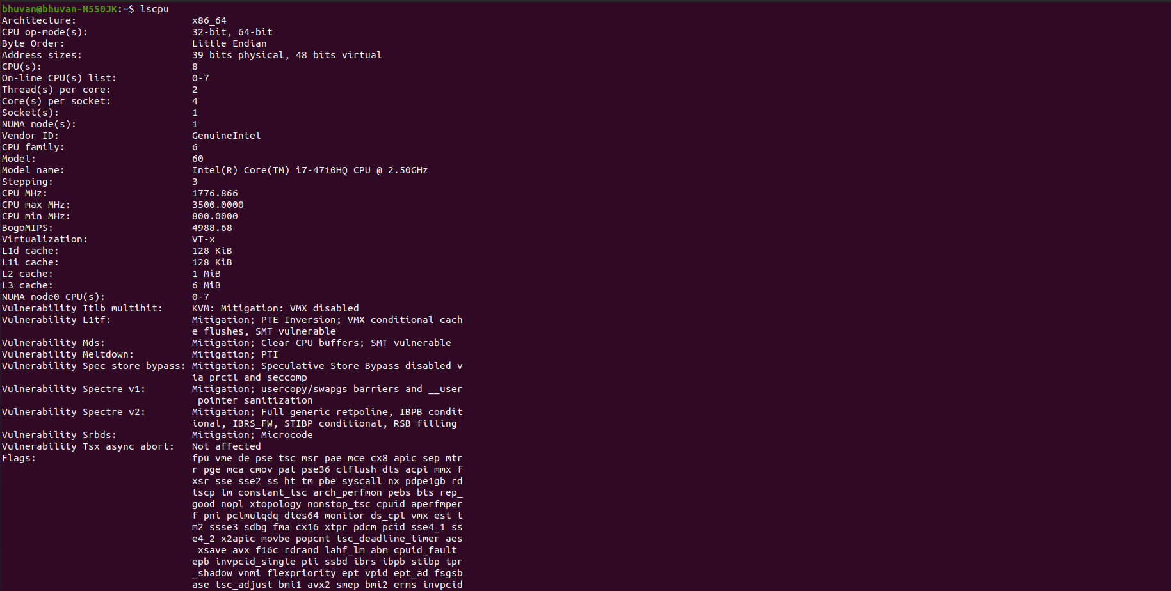
$ lscpu | egrep 'Model name|Socket|Thread|NUMA|CPU\(s\)'
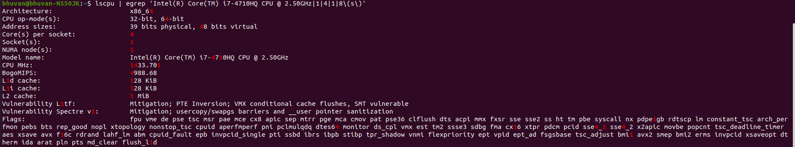
$ lscpu -p
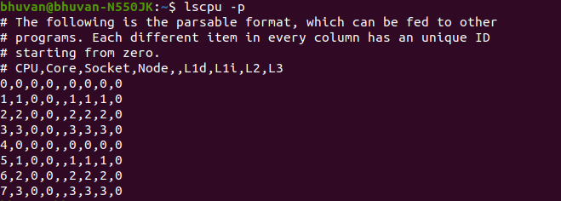
b) Run top or htop command to obtain the number of CPUs/cores in linux
$top
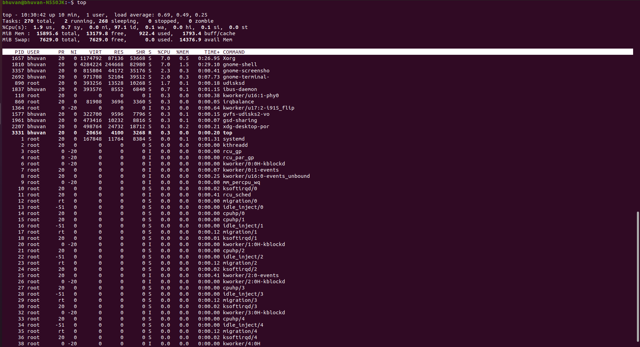
c) Execute nproc and print the number of CPUs available on Linux
$ nproc –all
$ echo "Threads/core: $(nproc –all)"

2.Write a C/C++ simple parallel program to display the thread_id and total number of threads. [3 Marks]
/*simpleomp.c*/
#include<omp.h>
int main(){
int nthreads,tid;
#pragma omp parallel private(tid)
{
tid=omp_get_thread_num();
printf(“Hello world from thread=%d\n”,tid);
if(tid==0)
{
nthreads=omp_get_num_threads();
printf(“Number of threads=%d\n”,nthreads);
}
}
}
Execute the program as follows:
$gcc –o simple –fopenmp simpleomp.c
$export OMP_NUM_THREADS=2
$./simple
Note down the output in your observation book.
Number of threads in a parallel region is determined by the if clause, num_threads(), omp_set_num_threads(), OMP_NUM_THREADS.
Use these various methods to set number of threads and mention the method of setting the same.
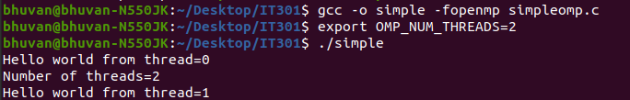
If clause
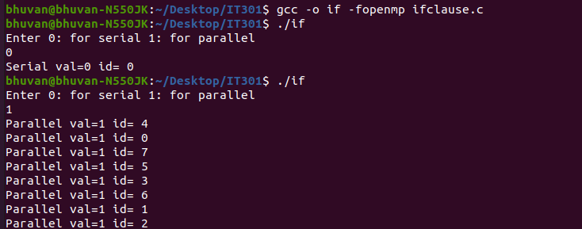
num_threads()
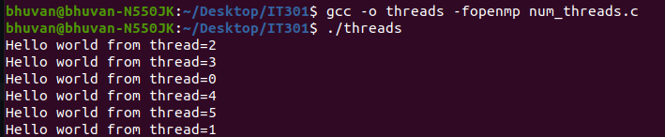
OMP_NUM_THREADS
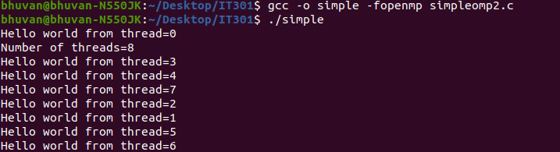
omp_set_num_threads()

2. Check the output of following program and Note down the output in your observation book. [2 Marks]
/*ifparallel.c*/
#include<omp.h>
int main(){
int val;
printf(“Enter 0: for serial 1: for parallel\n”);
scanf(“%d”,&val);
#pragma omp parallel if(val)
{
if(omp_in_parallel())
printf(“Parallel val=%d id= %d\n”,val, omp_get_thread_num());
else
printf(“Serial val=%d id= %d\n”,val, omp_get_thread_num());
}
}
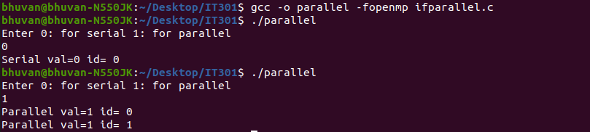
3.Observe and record the output of following program [2 Marks]
/*num_threads.c*/
#include<omp.h>
int main(){
#pragma omp parallel num_threads(4)
{
int tid=omp_get_thread_num();
printf(“Hello world from thread=%d\n”,tid);
}
}
Change the num_threads and observe the result.
No of threads=4
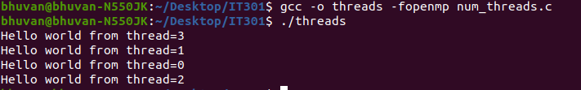
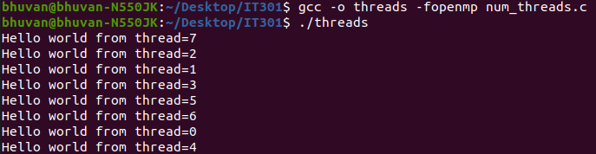
No of threads=8

